

This matter is being dealt with by:

**Claire Poole**

Reference: Proud to Care Awards

**T** 0115 9772923

**E** [enquiries@nottscc.gov.uk](mailto:enquiries@nottscc.gov.uk)

**W** nottinghamshire.gov.uk

|  |
| --- |
| Quality and Market Management Team  Nottinghamshire County Council  County Hall, Loughborough Road  West Bridgford  NOTTINGHAM  NG2 7QP |

##MAILMERGE - **Do not** delete this text or change the colour from white

To support an application for

Proud to Care Awards

28th November 2019

Dear Proud to Care Participant

Thank you for your participation in the Proud to Care Awards.

As your application includes the use of photographs and/or video clips I have taken advice from our Information Governance Team. They have confirmed that to comply with the new General Data Protection Regulation (GDPR), we need to have evidence on file to confirm that you have been made aware of your rights to choose whether or not your image(s) are used for the purpose of this nomination.

I would therefore be grateful if you would sign the form at the bottom of this letter to confirm that:

1. You understand why you are required to complete this form and the reasons why your consent is required.
2. You have been given the opportunity NOT to have your image used in this application.
3. You give your consent freely.

**For your information:**

**Privacy Notice** - The Council is committed to protecting your privacy and ensuring all personal information is kept confidential and safe. For more details see our general and service specific privacy notices at: <https://www.nottinghamshire.gov.uk/global-content/privacy>.

On behalf of the authority I can confirm that:

* no other details relating to the individuals, other than what appears on the footage of the film or their photograph, will be shared.
* The purpose of the photos and/or film, as you are aware, is to showcase your nomination/application for the Proud to Care Awards 2019. It will therefore be shared with the judging panel and then to showcase the excellent work taking place in Nottinghamshire.
* Some of the sharing methods used may include social media, such as Linked-In, uploaded to websites, including YouTube and by email to partner organisations within the health and social care sector.
* It could potentially be used in recruitment events and training events to support the excellent work and opportunities available in the social care sector.
* The material will be reviewed regularly and after 6 years from the date of launch, a decision will be taken as to its continued relevance. Should it be considered out of date, it will be removed from circulation. Thereafter it will be reviewed on an annual basis to check continued suitability.
* At any time during the 6-year period, should it become out of date, or should any of the people appearing in the film or photo wish to withdraw their consent, they should contact myself or the local authority at the address above.
* On receipt of a request to withdraw consent we will then cease to use and promote the video/photo and remove it from all the websites and platforms that can be identified.

Thank you for your support with the above and if you have any queries, please do not hesitate to contact me.

Yours sincerely

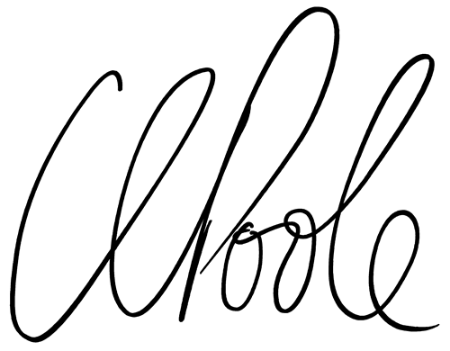

Claire Poole

Team Manager, Optimum Workforce Leadership

Quality and Market Management Team

Nottinghamshire County Council

**Agreement**

I understand the content of this letter and the implications of agreeing to appear in this film/photo, which is to support our application for the Proud to Care Awards.

Name: ________________________________________________

Job role: ________________________________________________

Organisation: ________________________________________________

Date: ________________________________________________